Updated 8/12/17

**Tutorial**

1. Refreshing the page added duplicates (see screenshot below)

I added “Test 4(Basic)” and when I refreshed the page, there was a duplicate. I refreshed again and another duplicate appeared.

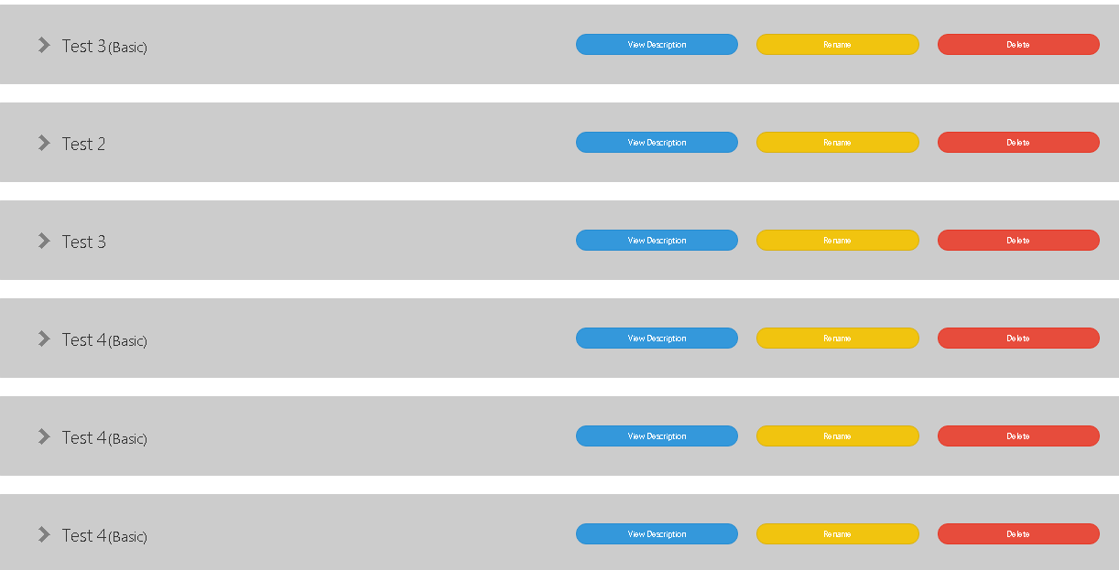

2. Topics are out of order

The topics were shuffled out of order when I went back to the main home screen and then clicked on “Tutorial” again. See screenshot below (Test 5 inserted between the Test 4(Basic) duplicates.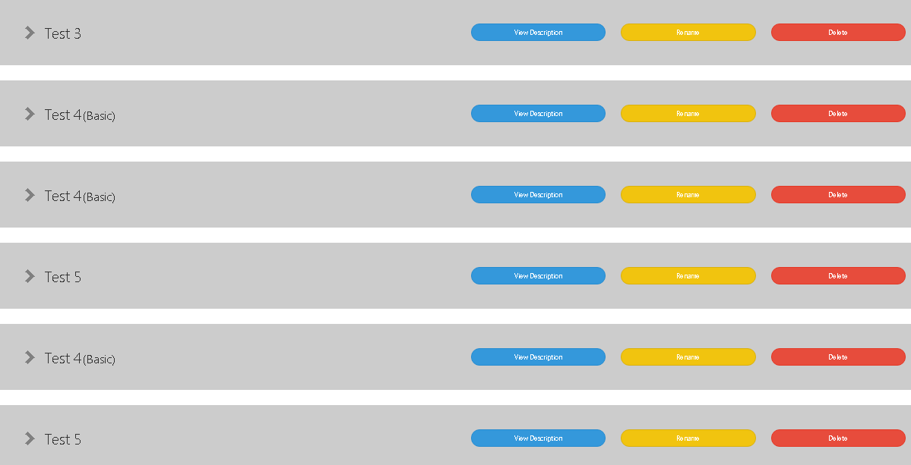

**Quiz**

1. The quiz answer text does not shrink to fit dialog box

